**Simulation User Interface Designs**

**Introduction**

The UI designs represent how the front end of the system will look and it is important to have an aesthetically pleasing look which attracts the users and also have a user friendly UI which users can easily navigate and understand how to use the website.

Below are examples of potential UI designs to choose from for the simulation feature.

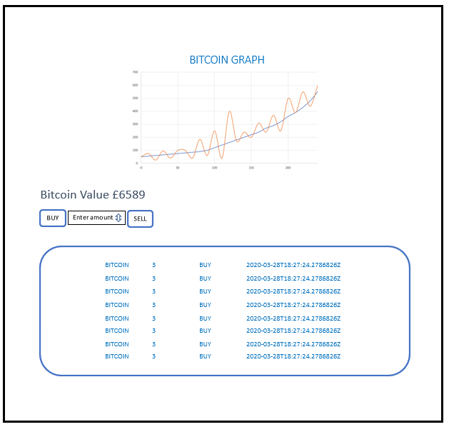Figure 1:

Figure 1 represents the graph first thing at the top, then has options to buy and sell with an amount to enter in the input text box. At the very bottom there is a transactions table that displays any transaction the user initiates within that portfolio. It is a very straight forward and simple design which wouldn’t confuse the user when on the website.

Figure 2:

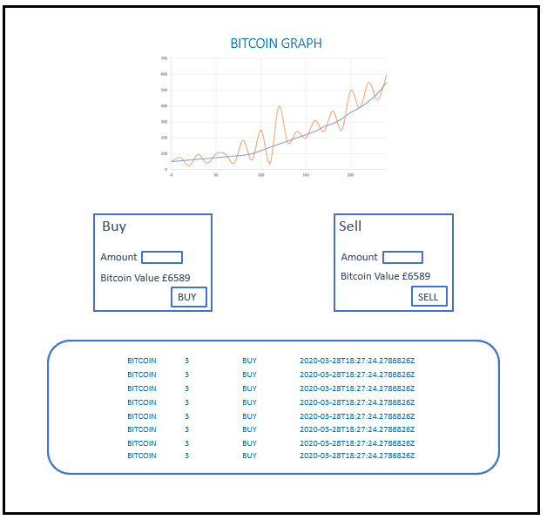

Figure 2 is a bit different to figure 1 and in this design, the buy and sell options have been separated into two sections which does make it clear for the user if they want to buy or sell.

To conclude, the simulation feature would be implemented using the first UI design in figure 2 as it is seen more straight forward for users.